EXPEREIMENT-3

Benchmarking of 5G/6G Communication
for IoE Applications based on Throughput, Latency, Reliability and Energy Efficiency

Objective:
To benchmark and compare 5G and 6G communication technologies for Internet of Everything (IoE) applications based on throughput, latency, reliability, and energy efficiency

Procedure :
- Identify suitable IoE applications and select 5G and 6G communication technologies for comparison.
- Select the performance parameters: throughput, latency, reliability, and energy efficiency.
- Collect or simulate 5G and projected 6G performance data.
- Compare both technologies using tables and graphs based on the selected parameters.
- Analyze the results to determine the suitability of 5G and 6G for different IoE applications.

Tabular column:

IoE Devices | 230 | 360 | 490
Offered Load | 44.16 Mbps | 69.12 Mbps | 94.08 Mbps
Throughput | 43.25 Mbps | 67.75 Mbps | 91.84 Mbps
Latency | 18.25 ms | 32.65 ms | 124.80 ms
Reliability | 90.15% | 85.40% | 80.25%
Energy Efficiency | 5.92 Mbit/J | 4.75 Mbit/J | 3.88 Mbit/J

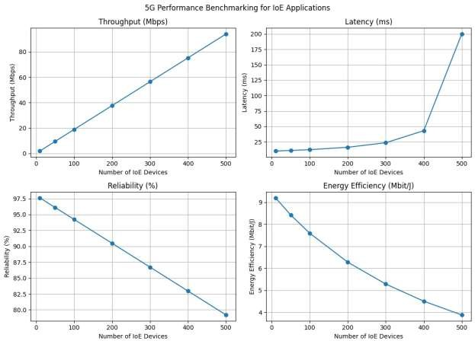

Result :
As the number of IoE devices increases, throughput increases, while latency, reliability, and energy efficiency decrease. Therefore, 5G is suitable for moderate-load IoE applications,
whereas 6G offers higher throughput for high-demand applications but requires improvements in latency, reliability, and energy efficiency.

